# **Model Tuning**[**¶**](https://kitt.lewagon.com/camps/1917/lectures/content/05-ML_05-Model-Tuning.html#Model-Tuning)

## **Recap from Under the Hood**

**Problem setting**

* X
* = features
* y
* = target =
* h
* (
* X
* ,
* β
* )
* +
* e
* r
* r
* o
* r
* h
* = hypothesis function (Linear, Logistic Regression, etc.)

**Parameters of the model:**

β

* computed automatically during .fit()
* by minimizing
* L
* (
* β
* )

**Hyperparameters of the model** (chosen manually)

* Loss Function
* L
* (MSE, Log-Loss, etc.)
* loss parameters (learning_rate, eta0, etc.)
* solver = method used to minimize
* L
* ('newton', 'sgd', etc.)
* model specificities ('n_neighbors', 'kernel', etc.)
* and more

# **Plan**

1. Model Complexity
2. Regularization
3. Model Tuning: Grid Search & Random Search
4. Support Vector Machines (Margin Classifiers)
5. Kernel Tricks

## **The Tuning Stage**

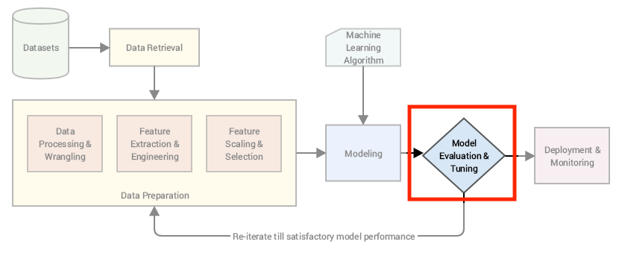

## **1. Model Complexity**

Let's remember Linear Regression:

Y

=

β

0

+

β

1

X

1

+

ϵ

❓What about non-linear behavior as below?

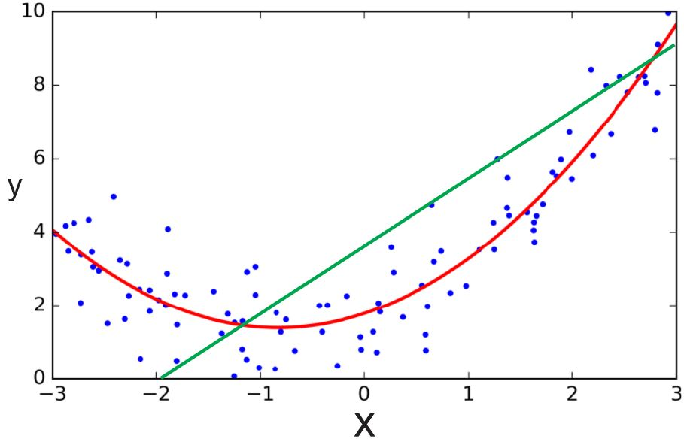

👉 If we add a new transformed feature

X

2

1

we have a better fit (in red)

Y

=

β

0

+

β

1

X

1

+

β

2

X

2

1

+

.

.

.

+

ϵ

🤔 We could engineer very complex features:

X

3

,

X

6

,

(

X

2

1

∗

X

5

2

)

,

.

.

.

Our

R

2

will keep increasing with every additional feature!

We just solved Data Science!

**def** train_best_model_ever(X,y):

**while** **True**:

model = LinearRegression()

model.fit(X, y)

**if** calculate_r2(model, X, y) < 0.999999:

X = add_more_crazy_features(X)

**else**:

**return** model

### **Overfitting and Underfitting**

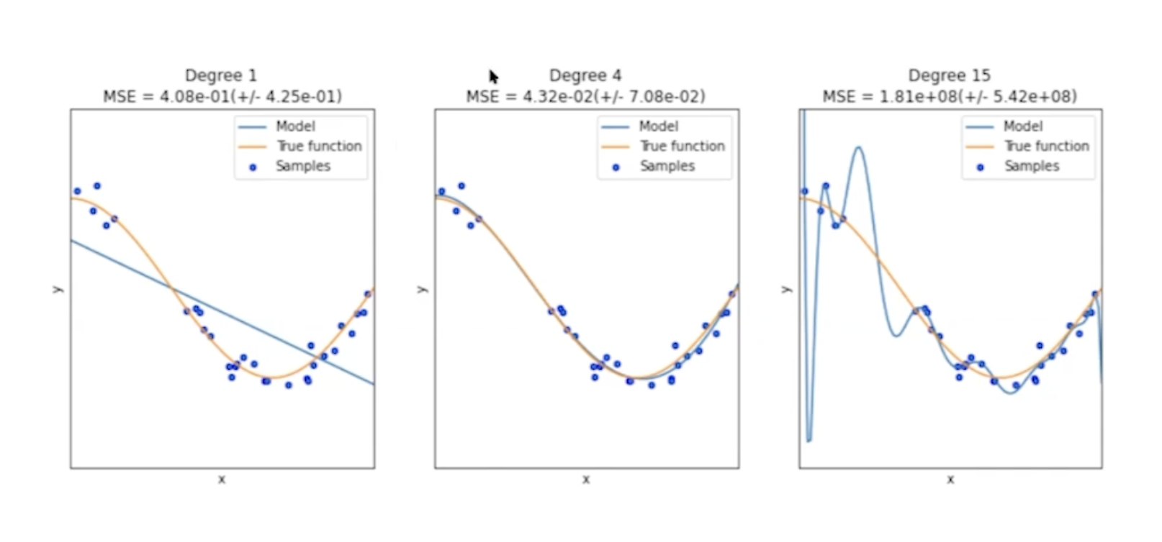

What's wrong with the first model? With the third?

* The first one does not capture all the information in the data (**high bias** model)
* The third one finds signals that aren't there (noise); it will not generalize well to new data points (**high variance** model)

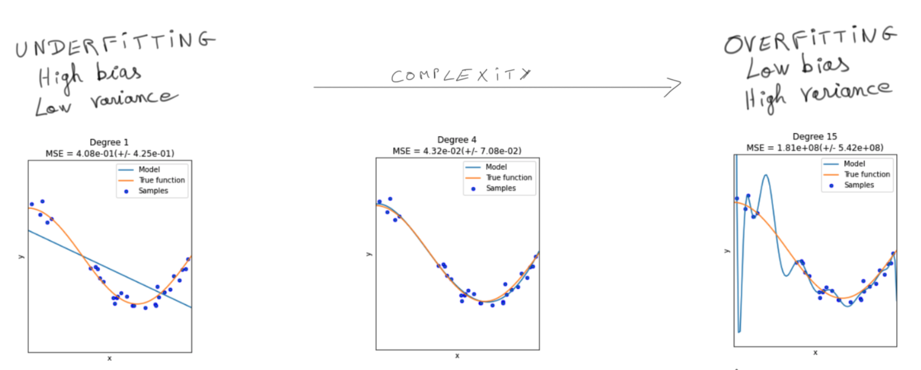

### **The Bias-Variance Tradeoff**

One of the most important concepts in Data Science!

Look at what happens in reality when measuring the error on an unseen **test set**:

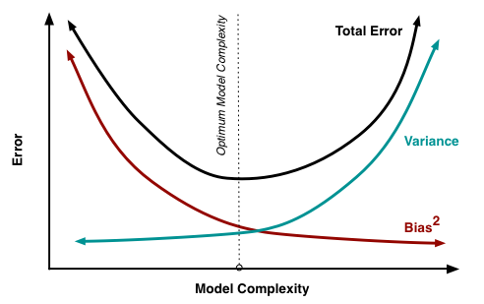

T

o

t

a

l

E

r

r

o

r

=

B

i

a

s

2

+

V

a

r

i

a

n

c

e

+

I

r

r

e

d

u

c

i

b

l

e

E

r

r

o

r

📚 [Great read](http://scott.fortmann-roe.com/docs/BiasVariance.html)

❓How do we find the optimal model complexity?

The one that minimizes the **test error** on an unseen dataset

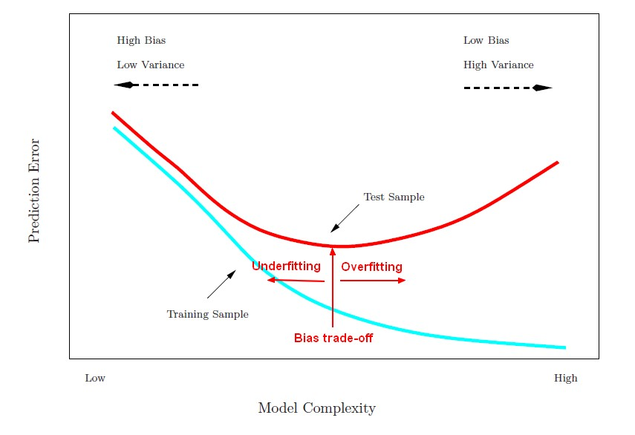

🤔 Don't have time to try many models?

Use **learning curves** to at least diagnose the only one you have!

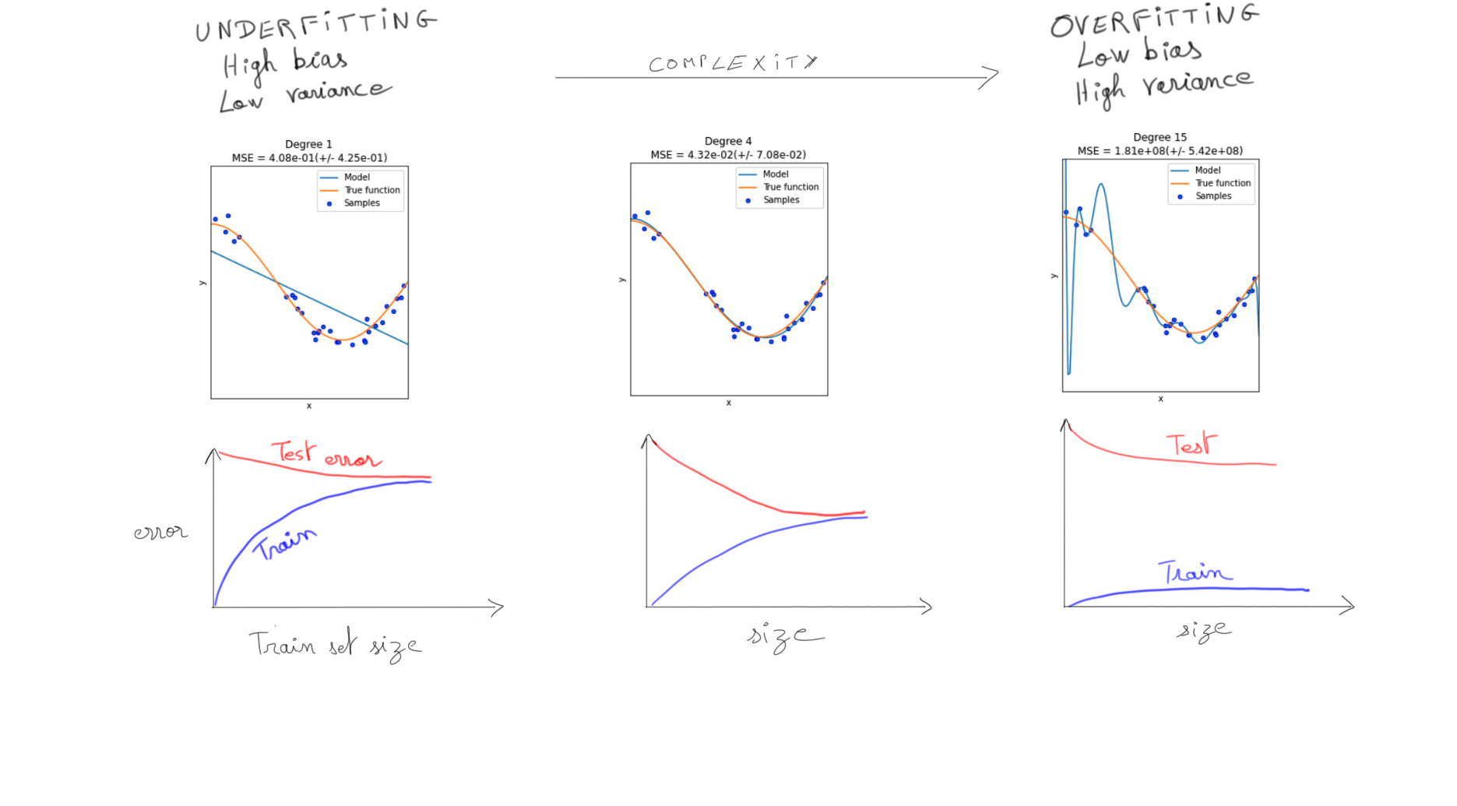

#### **❗️Data Leakage Reminder❗️**

Always diagnose your model using a **validation set**!



👉 **Cross-validate** instead of using a single holdout validation set to generalize better!

### **Solutions for Overfitting**

*Simplify* your model *relative* to your data

* Get more observations
* Feature selection (manual or [automated](https://scikit-learn.org/stable/modules/feature_selection.html))
* Dimensionality reduction (Unsupervised Learning)
* Early stopping (Deep Learning)
* **Regularization** of your Loss function

## **2. Regularization**

Regularization means adding a **penalty term** to the Loss that **increases** with

β

R

e

g

u

l

a

r

i

z

e

d

L

o

s

s

=

L

o

s

s

(

X

,

y

,

β

)

+

P

e

n

a

l

t

y

(

β

)

👉 Penalizes large values for

β

i

👉 Forces model to shrink certain coefficients or even select less features  
👉 Prevents overfitting

^

y

=

β

0

+

β

1

X

1

+

β

2

X

2

1

+

β

3

X

3

1

+

.

.

.

The two most famous Regularization penalties are:

R

i

d

g

e

(

X

,

y

,

β

)

=

∑

n

−

1

i

=

0

(

y

i

−

(

β

0

+

β

1

x

1

+

.

.

.

β

p

x

p

)

)

2

L

o

s

s

(

X

,

y

,

β

)

+

α

∑

p

j

=

1

β

j

2

L

a

s

s

o

(

X

,

y

,

β

)

=

∑

n

−

1

i

=

0

(

y

i

−

(

β

0

+

β

1

x

1

+

.

.

.

β

p

x

p

)

)

2

L

o

s

s

(

X

,

y

,

β

)

+

α

∑

p

j

=

1

|

β

j

|

❗️ ***Warning*** ❗️

When regularizing a Regression with a L2 penalty or with a L1 penalty:

* We regularize
* β
* 1
* ,
* .
* .
* .
* ,
* β
* p
* We do NOT regularize the intercept
* β
* 0
  + Keep in mind that Ridge reduces the influence of features with a non-significant coefficient
  + Keep in mind that Lasso shrinks them to zero
  + But
  + β
  + 0
  + is not associated with any feature!

New hyper-parameter

α

* Dictates **how much** the model is **regularized**
* Large
* α
* values force model complexity to decrease 👉 ⤵ variance, ⤴ bias

The sum starts from j = 1, we do **not** penalize the intercept coefficient

### **🖥 Comparing Ridge vs. Lasso?**

X, y = datasets.load_diabetes(return_X_y=**True**, as_frame=**True**)

X.head()

|  | **age** | **sex** | **bmi** | **bp** | **s1** | **s2** | **s3** | **s4** | **s5** | **s6** |
| --- | --- | --- | --- | --- | --- | --- | --- | --- | --- | --- |
| **0** | 0.038076 | 0.050680 | 0.061696 | 0.021872 | -0.044223 | -0.034821 | -0.043401 | -0.002592 | 0.019907 | -0.017646 |
| **1** | -0.001882 | -0.044642 | -0.051474 | -0.026328 | -0.008449 | -0.019163 | 0.074412 | -0.039493 | -0.068332 | -0.092204 |
| **2** | 0.085299 | 0.050680 | 0.044451 | -0.005670 | -0.045599 | -0.034194 | -0.032356 | -0.002592 | 0.002861 | -0.025930 |
| **3** | -0.089063 | -0.044642 | -0.011595 | -0.036656 | 0.012191 | 0.024991 | -0.036038 | 0.034309 | 0.022688 | -0.009362 |
| **4** | 0.005383 | -0.044642 | -0.036385 | 0.021872 | 0.003935 | 0.015596 | 0.008142 | -0.002592 | -0.031988 | -0.046641 |

y.head()

0 151.0

1 75.0

2 141.0

3 206.0

4 135.0

Name: target, dtype: float64

⚠️ Always **scale** your features before regularization to penalize each

β

i

fairly

(already scaled here)

**from** **sklearn.linear_model** **import** Ridge, Lasso, LinearRegression

linreg = LinearRegression().fit(X, y)

ridge = Ridge(alpha=0.2).fit(X, y)

lasso = Lasso(alpha=0.2).fit(X, y)

coefs = pd.DataFrame({

"coef_linreg": pd.Series(linreg.coef_, index = X.columns),

"coef_ridge": pd.Series(ridge.coef_, index = X.columns),

"coef_lasso": pd.Series(lasso.coef_, index= X.columns)})\

coefs\

.map(**lambda** x: int(x))\

.style.map(**lambda** x: 'color: red' **if** x == 0 **else** 'color: black')

|  | **coef_linreg** | **coef_ridge** | **coef_lasso** |
| --- | --- | --- | --- |
| **age** | -10 | 7 | 0 |
| **sex** | -239 | -182 | -75 |
| **bmi** | 519 | 457 | 511 |
| **bp** | 324 | 284 | 234 |
| **s1** | -792 | -48 | 0 |
| **s2** | 476 | -78 | 0 |
| **s3** | 101 | -189 | -170 |
| **s4** | 177 | 119 | 0 |
| **s5** | 751 | 400 | 450 |
| **s6** | 67 | 97 | 0 |

#### **What happens when alpha increases?**

| Ridge | Lasso |
| --- | --- |

* Increasing
* α
* in Ridge will only shrink parameters **toward 0**
* Increasing
* α
* in Lasso can shrink parameters **to 0** (natural feature selector)

### **ElasticNet = Lasso & Ridge Weighted Average**

L

=

∥

y

−

^

y

∥

2

+

α

(

λ

|

β

|

+

(

1

−

λ

)

∥

β

∥

2

)

2 hyper-parameters to fine-tune (

α

,

λ

)

**from** **sklearn.linear_model** **import** ElasticNet

model = ElasticNet(alpha=1, l1_ratio=0.2)

### **🤔 Which features are penalized?**

*# Let's check the p-values of our features before regularization*

**import** **statsmodels.api** **as** **sm**

ols = sm.OLS(y, sm.add_constant(X)).fit()

ols.summary()

| **Dep. Variable:** | target | **R-squared:** | 0.518 |
| --- | --- | --- | --- |
| **Model:** | OLS | **Adj. R-squared:** | 0.507 |
| **Method:** | Least Squares | **F-statistic:** | 46.27 |
| **Date:** | Thu, 09 Feb 2023 | **Prob (F-statistic):** | 3.83e-62 |
| **Time:** | 23:59:47 | **Log-Likelihood:** | -2386.0 |
| **No. Observations:** | 442 | **AIC:** | 4794. |
| **Df Residuals:** | 431 | **BIC:** | 4839. |
| **Df Model:** | 10 |  |  |
| **Covariance Type:** | nonrobust |  |  |

|  | **coef** | **std err** | **t** | **P>|t|** | **[0.025** | **0.975]** |
| --- | --- | --- | --- | --- | --- | --- |
| **const** | 152.1335 | 2.576 | 59.061 | 0.000 | 147.071 | 157.196 |
| **age** | -10.0099 | 59.749 | -0.168 | 0.867 | -127.446 | 107.426 |
| **sex** | -239.8156 | 61.222 | -3.917 | 0.000 | -360.147 | -119.484 |
| **bmi** | 519.8459 | 66.533 | 7.813 | 0.000 | 389.076 | 650.616 |
| **bp** | 324.3846 | 65.422 | 4.958 | 0.000 | 195.799 | 452.970 |
| **s1** | -792.1756 | 416.680 | -1.901 | 0.058 | -1611.153 | 26.802 |
| **s2** | 476.7390 | 339.030 | 1.406 | 0.160 | -189.620 | 1143.098 |
| **s3** | 101.0433 | 212.531 | 0.475 | 0.635 | -316.684 | 518.770 |
| **s4** | 177.0632 | 161.476 | 1.097 | 0.273 | -140.315 | 494.441 |
| **s5** | 751.2737 | 171.900 | 4.370 | 0.000 | 413.407 | 1089.140 |
| **s6** | 67.6267 | 65.984 | 1.025 | 0.306 | -62.064 | 197.318 |

| **Omnibus:** | 1.506 | **Durbin-Watson:** | 2.029 |
| --- | --- | --- | --- |
| **Prob(Omnibus):** | 0.471 | **Jarque-Bera (JB):** | 1.404 |
| **Skew:** | 0.017 | **Prob(JB):** | 0.496 |
| **Kurtosis:** | 2.726 | **Cond. No.** | 227. |

Notes:

[1] Standard Errors assume that the covariance matrix of the errors is correctly specified.

coefs_with_p_value

|  | **coef_linreg** | **coef_ridge** | **coef_lasso** | **p-values (%)** |
| --- | --- | --- | --- | --- |
| **age** | -10.009866 | 7.728551 | 0.000000 | 86 |
| **sex** | -239.815644 | -182.946743 | -75.612133 | 0 |
| **bmi** | 519.845920 | 457.176049 | 511.404133 | 0 |
| **bp** | 324.384646 | 284.516603 | 234.508645 | 0 |
| **s1** | -792.175639 | -48.471100 | -0.000000 | 5 |
| **s2** | 476.739021 | -78.867888 | -0.000000 | 16 |
| **s3** | 101.043268 | -189.672329 | -170.214828 | 63 |
| **s4** | 177.063238 | 119.682742 | 0.000000 | 27 |
| **s5** | 751.273700 | 400.706510 | 450.678492 | 0 |
| **s6** | 67.626692 | 97.378604 | 0.224852 | 30 |

☝️ Regularization *tends to* **penalize** features that are **not statistically significant**

### **Conclusions**

👉 **Regularize** when you think you are **overfitting** (e.g. Learning Curves not converging)

👉 **Ridge** when you believe all coefficients may have an impact

👉 **Lasso** as a feature selection tool (much better for interpretability!)

✅ Regularization is almost always appropriate

* Ridge is often turned on by default in most Machine Learning models
* You just have to tune the regularization parameter

## **3. Model Tuning**

❓ How to choose the best hyper-parameters (e.g: alpha)

### **The Grid Search Method**

*Explores different hyperparameter value combinations to find the combination which optimizes performance*

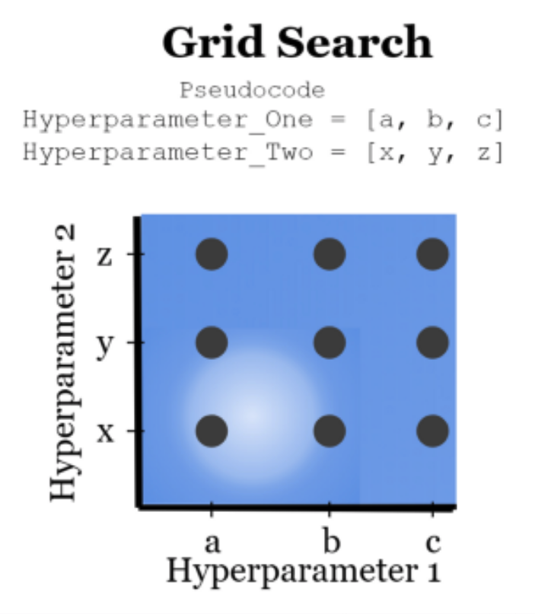

1. Hold out a *validation set* (never use the test set for model tuning!)
2. Select which grid of values of hyper-parameters to try out
3. For each combination of values, measure your performance on the *validation set*
4. Select hyper-parameters that produce the best performance

#### **💻 Let's (manually) fine-tune a linear model with** [**ElasticNet**](https://scikit-learn.org/stable/modules/generated/sklearn.linear_model.ElasticNet.html) **regularization**

**from** **sklearn.model_selection** **import** train_test_split

X_train, X_test, y_train, y_test = train_test_split(X, y, test_size=.20, random_state=1)

*# Select hyperparam values to try*

alphas = [0.01, 0.1, 1] *# L1 + L2*

l1_ratios = [0.2, 0.5, 0.8] *# L1 / L2 ratio*

*# create all combinations [(0.01, 0.2), (0.01, 0.5), (...)]*

**import** **itertools**

hyperparams = itertools.product(alphas, l1_ratios)

*# Train and CV-score model for each combination*

**from** **sklearn.linear_model** **import** ElasticNet

**from** **sklearn.metrics** **import** r2_score

**from** **sklearn.model_selection** **import** cross_val_score

**for** hyperparam **in** hyperparams:

alpha = hyperparam[0]

l1_ratio = hyperparam[1]

model = ElasticNet(alpha=alpha, l1_ratio=l1_ratio)

r2 = cross_val_score(model, X_train, y_train, cv=5).mean()

print(f"alpha: **{**alpha**}**, l1_ratio: **{**l1_ratio**}**, r2: **{**r2**}**")

alpha: 0.01, l1_ratio: 0.2, r2: 0.3097093011229858

alpha: 0.01, l1_ratio: 0.5, r2: 0.36553389455838525

alpha: 0.01, l1_ratio: 0.8, r2: 0.44169590096847555

alpha: 0.1, l1_ratio: 0.2, r2: 0.04607452785123458

alpha: 0.1, l1_ratio: 0.5, r2: 0.08029085880552811

alpha: 0.1, l1_ratio: 0.8, r2: 0.1778184138979217

alpha: 1, l1_ratio: 0.2, r2: -0.021420175696800325

alpha: 1, l1_ratio: 0.5, r2: -0.019482185329917502

alpha: 1, l1_ratio: 0.8, r2: -0.0114266833108428

#### **🔥 Grid Search CV**

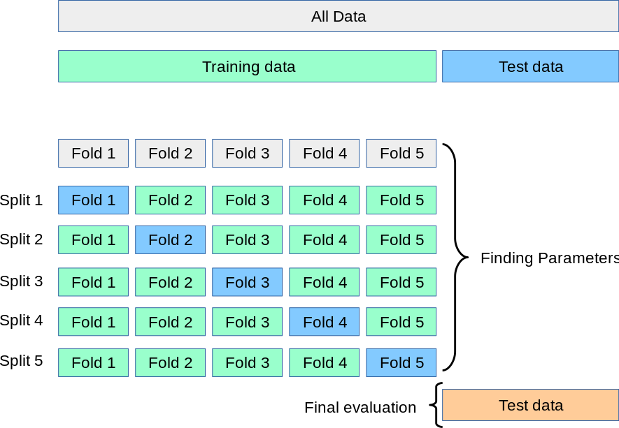

1. Randomy split your training set into k folds of same size
2. Make fold #1 a val_set, train model on other k-1 folds & mesure val_score
3. Make fold #2 a val_set and repeat
4. ...
5. Compute average val_score over all folds

☝️ This is your cross-validated score for **one** given set of hyper-parameters

* Repeat for each value of hyper-param to test
* Save the test set for final evaluation only (AFTER hyper-params are chosen)

### **Welcome to Sklearn** [**GridSearchCV**](https://scikit-learn.org/stable/modules/generated/sklearn.model_selection.GridSearchCV.html#sklearn.model_selection.GridSearchCV) **🚀**

**from** **sklearn.model_selection** **import** GridSearchCV

*# Train/Test split*

X_train, X_test, y_train, y_test = train_test_split(X, y, test_size=0.20, random_state=1)

*# Instantiate model*

model = ElasticNet()

*# Hyperparameter Grid*

grid = {

'alpha': [0.01, 0.1, 1],

'l1_ratio': [0.2, 0.5, 0.8]

}

*# Instantiate Grid Search*

search = GridSearchCV(

model,

grid,

scoring = 'r2',

cv = 5,

n_jobs=-1 *# parallelize computation*

)

*# Fit data to Grid Search*

search.fit(X_train, y_train);

*# Best score*

search.best_score_

*# Best Params*

search.best_params_

*# Best estimator*

search.best_estimator_

ElasticNet

ElasticNet(alpha=0.01, l1_ratio=0.8)

👎 Limitations of Grid Search:

* Computationally costly
* The optimal hyperparameter value can be missed
* Can overfit hyperparameters to the training set if too many combinations are tried out for too small a dataset

### **Random Search**

Randomly explore hyperparameter values from:

* A hyperparameter space to randomly sample from
* The specified number of samples to be tested

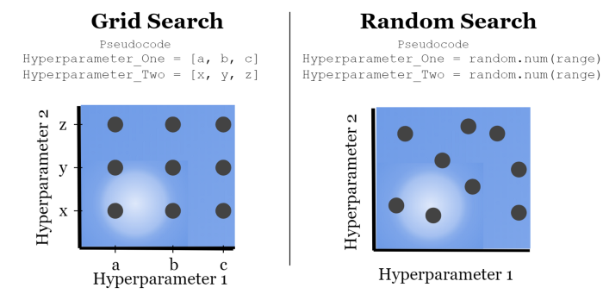

#### **Sklearn's RandomizedSearchCV**

**from** **sklearn.model_selection** **import** RandomizedSearchCV

**from** **scipy** **import** stats

*# Instantiate model*

model = ElasticNet()

*# Hyperparameter Grid*

grid = {'l1_ratio': stats.uniform(0, 1), 'alpha': [0.001, 0.01, 0.1, 1]}

*# Instantiate Grid Search*

search = RandomizedSearchCV(

model,

grid,

scoring='r2',

n_iter=100, *# number of draws*

cv=5, n_jobs=-1

)

*# Fit data to Grid Search*

search.fit(X_train, y_train)

search.best_estimator_

ElasticNet

ElasticNet(alpha=0.001, l1_ratio=0.7098199517233674)

#### **Choose hyperparameter probability distribution wisely**

Can be generated with [scipy.stats.distributions](https://docs.scipy.org/doc/scipy/reference/stats.html)

**from** **scipy** **import** stats

plt.figure(figsize=(5, 3))

dist = stats.norm(10, 2) *# if you have a best guess (say: 10)*

dist = stats.randint(1,100) *# if you have no idea*

dist = stats.uniform(1, 100) *# same*

dist = stats.loguniform(0.01, 1) *# Coarse grain search*

r = dist.rvs(size=10000) *# Random draws*

plt.hist(r);

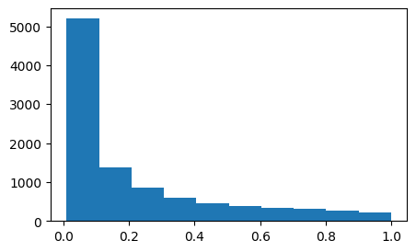

loguniform is great for coarse-grain search across several orders of magnitude

e.g. loguniform(0.01, 1) search over [

10

−

2

,

10

−

1

,

10

0

]

|  |  |
| --- | --- |

[Doc](https://docs.scipy.org/doc/scipy/reference/generated/scipy.stats.loguniform.html)

### **RandomizedSearch vs GridSearch**

👉 Randomized Search:

* Less typing, if you want to try many values
* Control for the number of combinations to try & time spent searching
* Useful when some hyper-parameters are more important than others

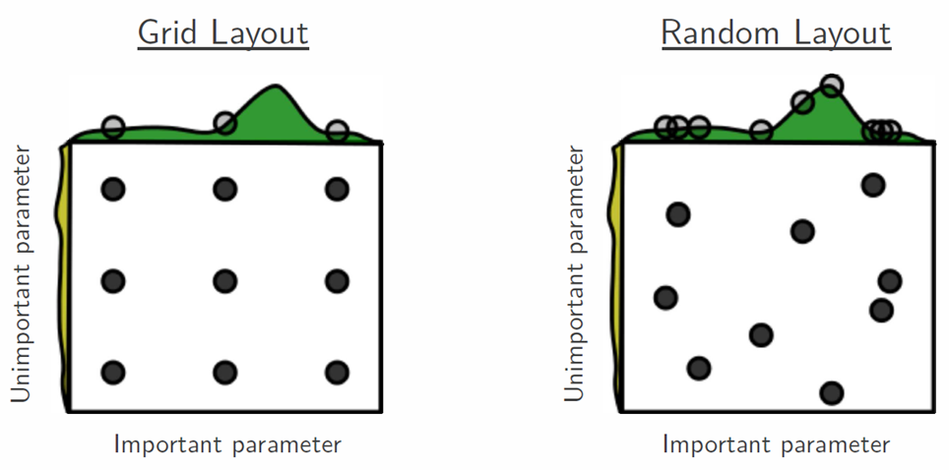

In any case:  
✅ Always start with a coarse grain approach (can use Grid or RandomSearch)  
✅ Then afterward, fine-tune your search

### **🔥 Key Summary 🔥**

**FIT** = finding the best **PARAMETERS** that minimize the **LOSS**

**FINE-TUNE** = finding the best **HYPERPARAMETERS** that maximize **PERFORMANCE METRICS**

## **4. Support Vector Machines (SVMs)**

#### **What's a good decision boundary for classification?**

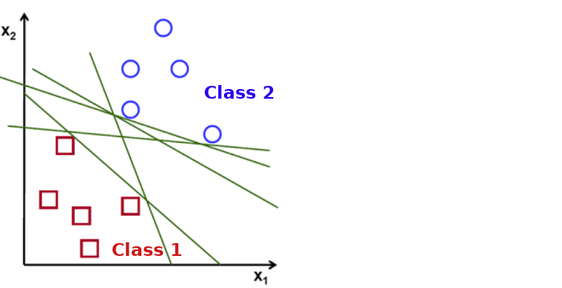

Infinite number of potential decision boundaries that separate the classes ("hyperplanes")

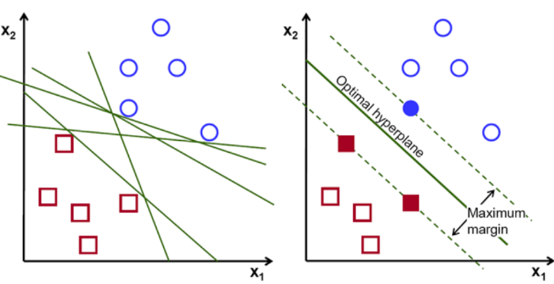

* The hyperplane that generalizes best to unseen data is the one that is furthest from all the points (maximizes the **margin**)
* The points on the margin boundary are called **support vectors**
* Finding them is a convex optimization problem (one single best solution)
* --> **Maximum Margin Classifier** algorithm

🤔 When would such a model be problematic?

* Max Margin is super sensitive to outliers
* It **overfits** to the training data

For **generalization** purposes, we may want to allow some points to be **inside** the margin, or even **on the other side** of the decision boundary:

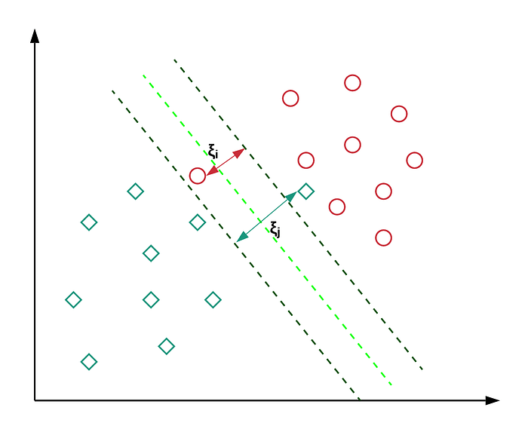

### **👉 Soft Margin Classifier**

Allows a few points to be misclassified but with a **penalty(**

ξ

**)**

Penalty for how "far" (

ξ

) they lie on the wrong side of the margin

The **Hinge Loss** is the penalty applied to each point on the wrong side

* The deeper a point lies within the margin, the higher the loss
* The penalty is linear, like MAE

|  |  |
| --- | --- |

❓ **How strong** should the penalty be for wrongly classified datapoints?

↔

How steep should the hinge loss be?

↔

How narrow should the margin be?

**Tradeoff** between classifying training data well and generalizing to new data

Bias vs. Variance tradeoff again!

* Solution? **Regularization**

### **Regularization hyperparameter C**

Strength of the penalty applied on points located on the wrong side of the margin

* The higher C, the stricter the margin
* A "maximum margin classifier" has C =
* +
* ∞
* The smaller C, the softer the margin, the more it is **regularized**
* C is similar to
* 1
* /
* α
* in Ridge

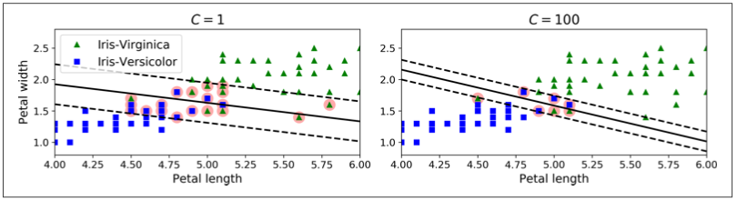

💻 sklearn implementation

**from** **sklearn.svm** **import** SVC

svc = SVC(kernel='linear', C=10)

*# equivalent but with SGD solver*

**from** **sklearn.linear_model** **import** SGDClassifier

svc_bis = SGDClassifier(loss='hinge', penalty='l2', alpha=1/10)

⚠️ Warning: All support vector models require **scaling**

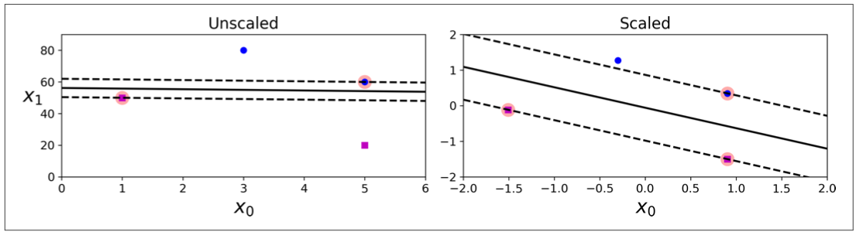

### **(Bonus) SVM Regressors**

The trick is to reverse the objective:

* **Classification**: fit the largest possible *street* **between** two classes
* **Regression**: fit as many points as possible **within** the *street*
* Width of the street controlled by an additional hyperparam epsilon
* ϵ
* 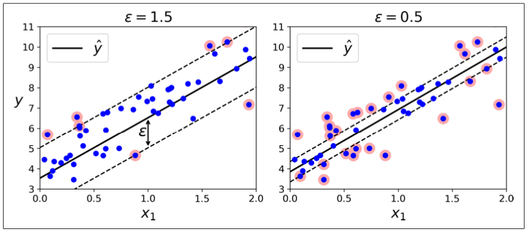

**from** **sklearn.svm** **import** SVR

regressor = SVR(epsilon=0.1, C=1, kernel='linear')

## **5. SVM Kernels (Keep for Recap 🕔)**

Fitting a **Linear SVM** is finding the best vector **w**

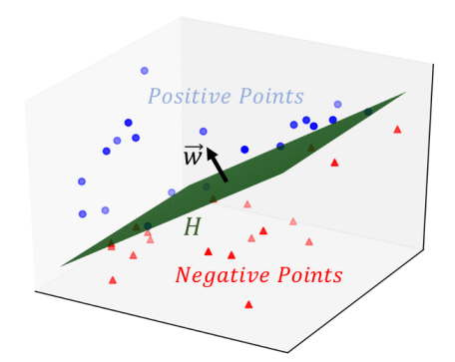

* whose **direction** uniquely determines the decision boundary hyperplane (orthogonal)
* which minimizes the sum of **hinge losses** for outliers

#### **What about this?**

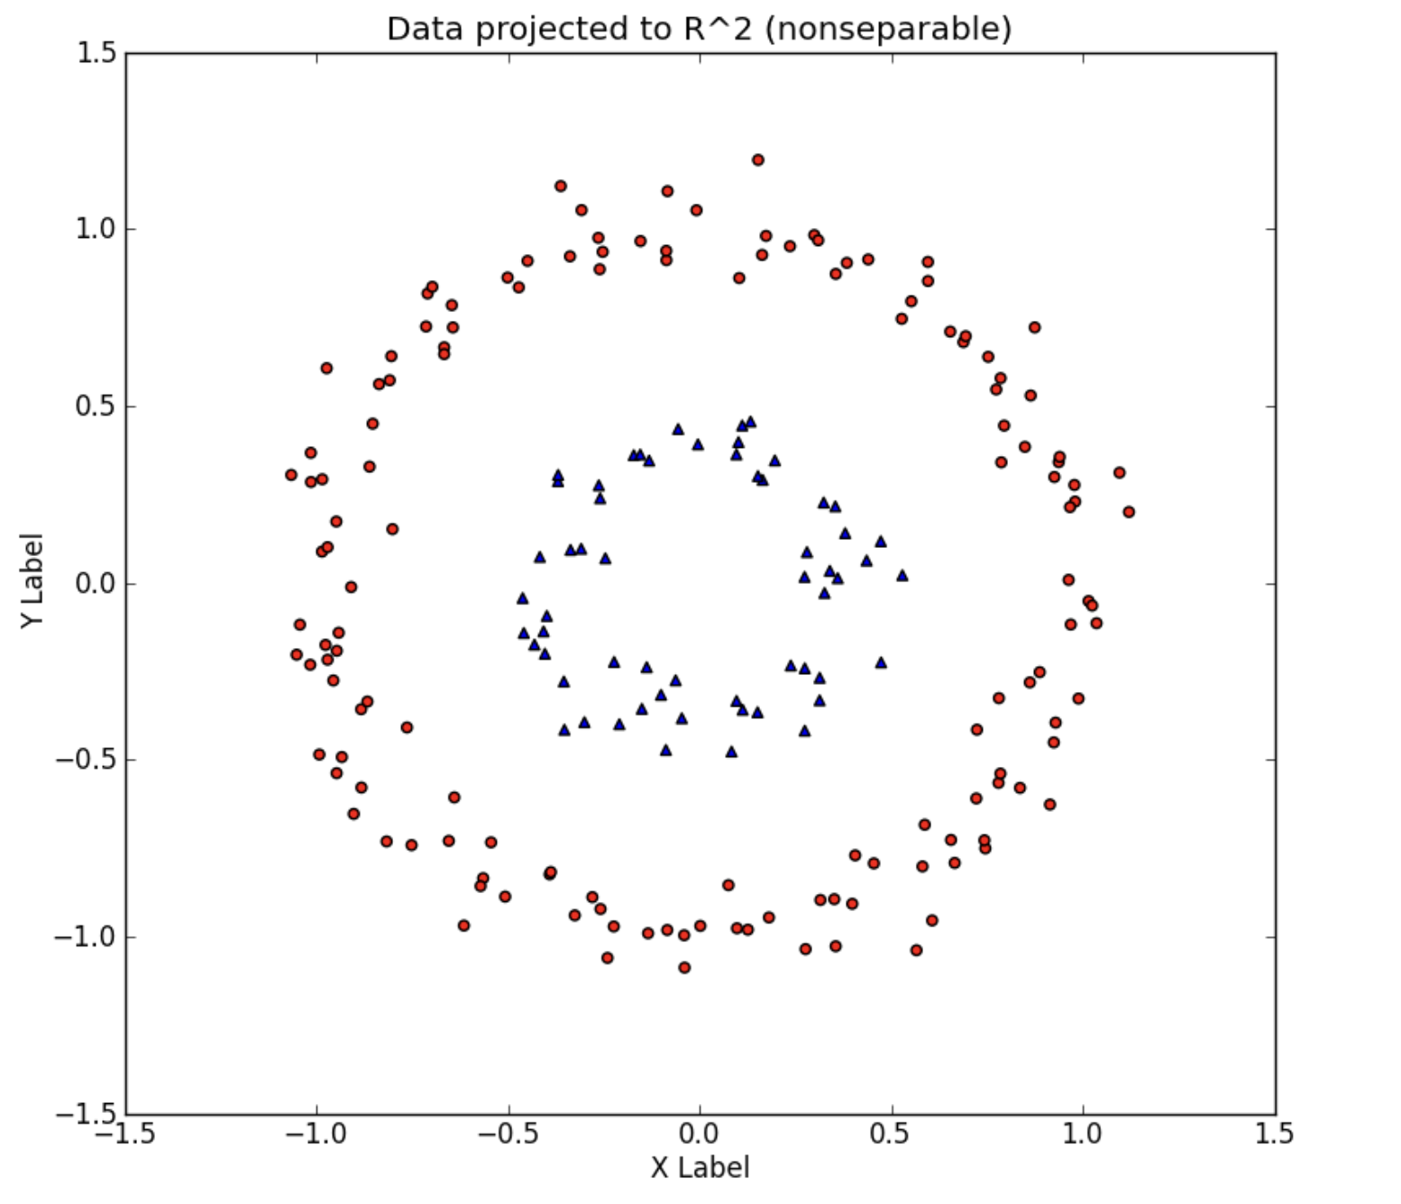

Not linearly separable!

We could add a new feature

Z

=

(

X

2

+

Y

2

)

In a higher dimension, the data becomes **linearly** separable again!



What we just did is a **feature mapping**

ϕ

from 2D to 3D

ϕ

(

[

x

1

x

2

]

)

=

⎡

⎢

⎣

x

1

x

2

x

2

1

+

x

2

2

⎤

⎥

⎦

More precisely, a polynomial mapping of degree d=2

🤯 **Problem:** we have increased the dimensionality of our feature space!

Running an expensive SVM in higher dimensions can become extremely intensive

#### **The Kernel Trick 🔥**

Instead of explicitly creating all the new features, smart people came up with a very clever "trick":

* Each time the loss function is calculated, it calculates a sort of **similarity**
* K
* (
* a
* ,
* b
* )
* between all pairs of data points, called a **Kernel**
* Two points with large a similarity would be classified similarly
* We can **simulate** feature mapping by wisely replacing the Kernel of the Loss Function
* Much more computationally **efficient**

📚 [Read more](https://xavierbourretsicotte.github.io/Kernel_feature_map.html)

#### **List of SVM Kernels**

kernel specifies the type of **feature mapping** to be used to make data **linearly separable** again

* linear
* poly (of dimension d)
* rbf ([radial basis function](https://en.wikipedia.org/wiki/Radial_basis_function) of coef gamma)
* sigmoid (of coef gamma)

C is the **strength** of the cost associated with the **wrong classification**

### **5.2 Kernel details**

#### **a) Linear Kernel**

This is the hypothesis function

h

w

(

X

)

of a Linear SVM

h

w

(

X

)

=

{

0

if

w

T

x

<

−

1

1

if

w

T

x

≥

1



☝️ We say that the **Kernel** of Linear the SVM is

K

(

a

,

b

)

=

a

T

b

K

(

a

,

b

)

=

a

T

b

→

ϕ

(

x

)

=

[

x

1

x

2

]

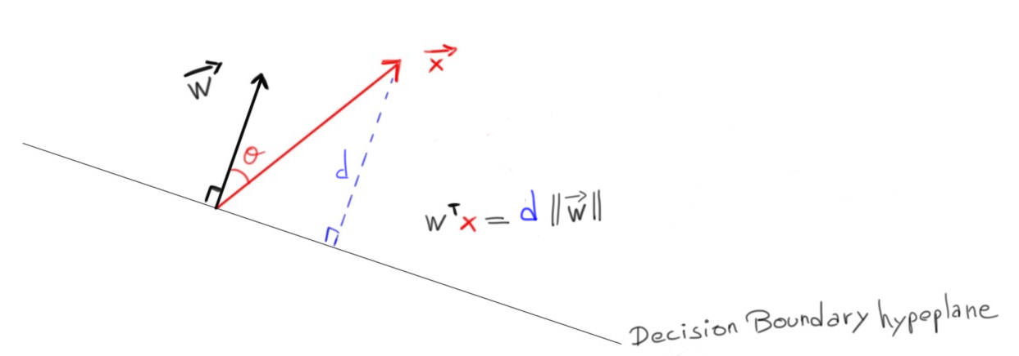

💡Notice that

w

T

x

is proportional to the perpendicular distance

d

to the decision boundary hyperplane

#### **b) Polynomial Kernel (order 2)**

K

(

a

,

b

)

=

(

a

T

b

+

c

)

2

→

ϕ

(

x

)

=

⎡

⎢

⎢

⎢

⎢

⎢

⎢

⎢

⎢

⎢

⎢

⎣

x

2

1

x

1

x

2

x

2

x

1

x

2

2

√

2

c

x

1

√

2

c

x

2

⎤

⎥

⎥

⎥

⎥

⎥

⎥

⎥

⎥

⎥

⎥

⎦

**Polynomial Kernel order of d**

K

(

a

,

b

)

=

(

a

T

b

+

c

)

d

The polynomial kernel also allows fitting non-linear **regressions** very easily

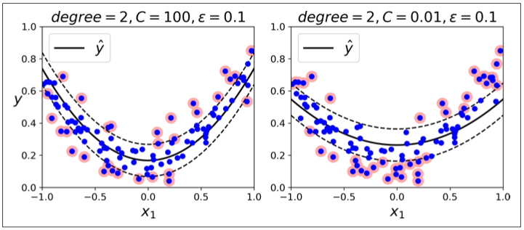

regressor = SVR(epsilon=0.1, C=1, kernel='poly', degree=2)

Source: [Hands-On Machine Learning with Scikit-Learn, Keras, and TensorFlow](https://www.oreilly.com/library/view/hands-on-machine-learning/9781492032632/)

#### **c) The RBF Kernel (aka Gaussian)**

*👇 exponentially decreasing value of the distance between the two points a and b*

K

(

a

,

b

)

=

exp

[

(

−

γ

|

|

a

−

b

|

|

2

)

Similarity between two datapoints is "gaussian"

Two points far away from one another are exponentially more likely to be different.

γ

acts as a *myopia* factor.

👉 **Increasing**

γ

**makes model overfit**

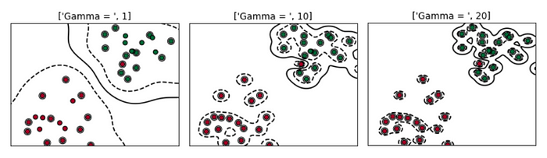

## **Recommended reads**

* 📚 Hands-on Machine Learning with Sklearn (2020), Chapter 5 SVM Section "under the hood"
* [Kernels explained](https://xavierbourretsicotte.github.io/Kernel_feature_map.html) (Math)
* [SVM vs Logistic Regression](http://www.cs.toronto.edu/~kswersky/wp-content/uploads/svm_vs_lr.pdf) (Math)

# **Your turn! 🚀**